**PROJECT INFORMATION**

|  |  |
| --- | --- |
| Project Title | Smart Parking Lot |
| Start Date – End Date | Start: 09/21/2016 End: 11/05/2016 |
| Lead Institution | Nguyen Thi Anh Nguyet |
| Project Manager & Contact detail | Nguyen Thi Anh Nguyet & Enterprise Business Parking Lot |
| Partner Organization | Enterprise Business Parking Lot |
| Project member | Truong Tan Luan  Nguyen Viet Huynh  Tran Thanh Huy  Vuong Nhat Quang |

**DOCUMENT NAME**

|  |  |
| --- | --- |
| Document Title | Proposal document |
| Author | Nguyen Thi Anh Nguyet |
| Role | Leader |
| Filename | Proposal_Smart Parking Lot |

**Document Approvals:** The following signatures are required for approval of this document.

|  |  |  |
| --- | --- | --- |
| Mr Johny Tran  CyberSoft Global Corporation (Vietnam) |  | 09/10/2016 |
| Nguyen Thi Anh Nguyet |  | 09/10/2016 |

CONTENTS

I. SOFTWARE REQUIREMENT SPECIFICATION 3

1. INTRODUCTION 3

1.1 Purpose 3

1.2 Scope 3

2. PROJECT OVERVIEW 4

2.1 Project definition 4

2.2 Business Needs 4

2.3 Business Values 5

2.4 Prior Art 5

2.5 Proposed Solution 5

2.5.1. Vision of the Solution 5

2.5.1.1 Vision Statement 5

2.5.1.2. Major Features 6

2.5.1.3. Assumptions and Dependencies 6

2.5.2. Scope and Limitations 7

2.6. List of Actors 8

2.7. User Story 9

2.8. List of Use Case 11

2.9. Use Case Detail 12

2.10. Context Diagram 21

2.10.1. System context 21

2.10.2. System Context Description 21

2.11. Use CaseDiagram 21

4. EXPECTED OUTCOME 25

5. METHOD/APPROACH___________________________________________ 26

5.1. Process oveIn trview 26

5.2. Tool and technical 28

II. WORK BREAKDOWN SYSTEM 28

III. PLAN 29

IV. REQUIREMENT PHASE 29

1. **SOFTWARE REQUIREMENT SPECIFICATION**
2. **INTRODUCTION**

The document describe overview of our job website for Vietnamese developer

and student who is senior student or just graduated and have not experience, our

expectations of website and the characteristics of the proposed solution for biding

jobs website.

The intended audience of the Proposal:

* The customer.
* Project managers (PMs).
* Project team.
* And any other stakeholders involved in carrying out the project.

## Purpose

* The document provides an overview of the project includes the

purpose and scope of project.

* In addition, identify business needs, problems or situation related to the initialization and construction projects.
* Provide solution for business needs
* Provide overview about resources, schedule, risk, solution and budget for the project.

## 1.2 Scope

* This document provides an overview of project will be developed. It includes overview of the product, overview of the process and overview of the project team.
* This document provides a plan for each phase of software development process based on waterfall process include: requirement, design, implementation, verification and maintenance. This is the general plan and will be updated with detail of the software development process in the next version of document.
* Proposal includes the introduction of solutions, determine the best way to develop software that we make, the total estimated costs, payback period, breakeven volume for the project.

1. **PROJECT OVERVIEW**

## Project definition

< Background>

Smart parking lot valued choices for future. On the world have quite a lot of this technology, but in vietnam yet common. Only HO CHI MINH and HA NOI sore neck this technology. In vietnam have traffic terrain unplanned an organized planning and futuristic. So roads pretty cramped, many family have need travel by modern means. The traffic congestion is increasing. Statistically and find out then i’ve see the garage below roadway pretty much. Especially car and pickups on the roads small. Out HO CHI MINH and HA NOI solution build underground parking below apartment but only meet a fraction. That's two points in the country, out DA NANG city above issues without exception, the general state of the country. So project Smart parking lot be thought of. It has many advantages such: Easy parking and vehicle management, not cause traffic jam, safety for users.

## Business Needs

< Customer or Market Needs>< Business Objectives>

The needs of today's users business need functions of Smart parking lot as: convenient, easily search for vacancies when parking, easy payment, high security system, vehicle safety, easy manager and revenue.

## Business Values

Save time, no collision when parking, safe drivers love, avoid the maximum impact from the environment.

## Prior Art

<Business Opportunity>

Intelligent Parking M5 building Nguyen Chi Thanh Hanoi: build yet save space, payment by card and cash, be time-consuming and difficult to manage, do not be quick.

Keep the car manually: not manage media, payment by cash, not safety for media, not manageable revenue.

My System: payment fast, not card, not cash, safety users, safety media, save space, high security, and login by fingerprints.

## . Proposed Solution

## Vision of the Solution

## . Vision Statement

For<Business Enterprises Parking> Who <a system smart parking> The< smart parking lot> Is a<application> That<Our software help easily manager, not cause traffic jams, safe for people to buy cars packed house, secure protection when it rains, the street landscape protection, can build economically sound unfortunately does not stretch underground, save time >unlike< Send car manually, managing costly and risks, yet modern nature. Mart parking lot today card payment and cash, yet fast, security not good>our product or service< Our products optimized fast and safe, save space, fast payment, high security>

* + - 1. **Major Features**

MF1: Register account

MF2: Login

MF3: Logout

MF4: To pass

MF5: Send and retrieve cars

MF6: Post comments

MF7: Payment

## 2.5.1.3. Assumptions and Dependencies

AS-1: The system is connected to a LAN to handle the In / Out ports (unlimited number of ports In - Out): Car In this gate (shooting mechanism), but the output would still show a picture when car into.

AS-2: All will be looking under the car and fingerprints. Backup function to save data in case of power failure, and especially the "black box" that allows to retain all activities in place.

DE-1: All information about the car, vehicles, vehicle number, date and time of parking, deposit cost data are stored on the computer. Ensuring the safety of our customers and keep the car owners.

DE-2: This system help many company and business save they time and money to order lunch for their staffs. So Smart Parking Lot can attract investment of many company and business.

## Scope and Limitations

|  |  |  |
| --- | --- | --- |
|  | **Rule** | **Benefit** |
| **Customer** | Provide funding for the system. | * See the total revenue and view statistics. |
| **PM** | Control the system. | * Login and logout the system. * Update the system. * Find users. * Add and delete users. * Post the notice. * Repair of user information |
| **User** | I­­ndirect participation. | * Find and send the car by fingerprint. * Register or delete account. * Payment the money by credit card or bank account. * The system to notify when your account runs out of money. * Supports multiple English and Vietnamese languages. * Support to search for your car position. |

* 1. **List of Actors**

|  |  |
| --- | --- |
| **Customer** | View sales statistics, changesr equirements to the system. |
| **Users** | Indirect participation at the system, send and take vehicles. |
| **Admin** | The look and dare to look at the system, have the right to change, additional information in the system. be trained to control the system. |

* 1. **User Story**

|  |  |  |
| --- | --- | --- |
| ID | Description | Prioritization |
| **UR1** | As a admin, i want to login on system. | H |
| **UR2** | As a admin, i want to logout on system. | H |
| **UR3** | As a admin, i want to add users. | H |
| **UR4** | As a admin, i want to delete users. | H |
| **UR5** | As a admin, i want to update users information. | H |
| **UR6** | As a admin, i want to cancel users information. | M |
| **UR7** | As a admin, i want to save users information daily. | M |
| **UR8** | As a admin, i want to add parking lot. | L |
| **UR9** | As a admin, i want to cancel parking lot. | L |
| **UR10** | As a admin, i want to check parking lot. | L |
| **UR11** | As a admin, i want to monitoring mart parking lot. | M |
| **UR12** | As a user, I want to register account. | H |
| **UR13** | As a user, I want to changes the password so that I want to find my account by email or phone number. | L |
| **UR14** | As a user, I want to delete my account. | M |
| **UR15** | As a user, I want to payment the money by credit card. | M |
| **UR16** | As a user, I want to payment the money by bank account. | L |
| **UR17** | As a user, I want to send the car by fingerprint. | H |
| **UR18** | As a user, I want to take the car by fingerprint. | H |
| **UR19** | As a user, I want to have the system to notify when my account runs out of money. | L |
| **UR20** | As a user, I want to have the system to search for vacancies me. | M |
| **UR21** | As a user, I want to have the system supports multiple English and Vietnamese languages. | H |
| **UR22** | As a user, I want to have support systems manual. | M |
| **UR23** | As a user, I want to systematically support the user-friendly. | M |
| **UR24** | As a user, I want to know the history of park. | L |
| **UR25** | As a customer, I want a system which intelligent, modern, vitality for car and motorbike | M |
| **UR26** | As a customer, I want profit | M |
| **UR27** | As a customer, I want your software is used everywhere and widely | M |
| **UR28** | As a customer, I want your software upgrades everyday | M |
| **UR29** | As a customer, I want your software must highly secure | H |
| **UR30** | As a customer, I want your software friendly with user | L |
| **UR31** | As a customer, I want to statistics financial | L |
| **RU 32** | As a customer, I want your software developed around the world | M |

* 1. **List of Use Case**

|  |  |  |  |  |  |
| --- | --- | --- | --- | --- | --- |
| **ID** | **Use Case Name** | **Primary Actor** | **Scope** | **Complexity** | **Priority** |
| **1** | Login | Admin, User | In | H | 1 |
| **2** | Logout | Admin, User | In | H | 1 |
| **3** | Add User | Admin | In | H | 1 |
| **4** | Delete User | Admin | In | M | 2 |
| **5** | Update Users Information | Admin | In | L | 3 |
| **6** | Cancel Users Information | Admin | In | L | 3 |
| **7** | Add Parking Lot | Admin | In | M | 2 |
| **8** | Cancel Parking Lot | Admin | In | L | 3 |
| **9** | Check Parking Lot | Admin | In | H | 1 |
| **10** | Credit Card | User | In | H | 1 |
| **11** | Bank Account | User | In | H | 1 |
| **12** | Changes The Password | User | In | H | 1 |
| **13** | Delete My Account | User | In | M | 2 |
| **14** | History | User | In | H | 1 |
| **15** | Send The Car | User | In | H | 1 |
| **16** | Take The Car | User | In | H | 1 |
| **17** | Languages | User, Admin | In | M | 3 |
| **18** | Upgrades | Customer | In | H | 1 |
| **19** | Statistics Financial | Customer | In | H | 1 |

* 1. **Use Case Detail**

|  |  |
| --- | --- |
| **Use Case ID** | **UC1** |
| Name | Login |
| Description | Admin login on the system by this account |
| Actor | Admin |
| Precondition | Internet, admin and user must have account |
| Basic of Friends | Steps 1. Enter user name and password  Steps 2. The system check account, if enter wrong user name or password, the system require you re-enter user name and password  Steps 3. If enter the connect account user name and password, the system will display the following functions |

|  |  |
| --- | --- |
| **Use Case ID** | **UC1** |
| Name | Login |
| Description | User login on the system by this account |
| Actor | User |
| Precondition | Internet, user must have account |
| Basic of Friends | Steps 1. Enter fingerprints  Steps 2. The system check account, if enter wrong fingerprints, the system require you re-enter fingerprints  Steps 3. If enter the connect account fingerprints, the system will display the following functions |

|  |  |
| --- | --- |
| **Use Case ID** | **UC2** |
| Name | Logout |
| Description | Admin logout on the system by their account |
| Actor | User |
| Precondition | Internet, user must be logged into the system |
| Basic of Friends | Steps 1. Enter into logout on the system  Steps 2. The system will show” got rid of the system ” |

|  |  |
| --- | --- |
| **Use Case ID** | **UC2** |
| Name | Logout |
| Description | Admin logout on the system by their account |
| Actor | Admin |
| Precondition | Internet, admin and user must be logged into the system |
| Basic of Friends | Steps 1. Enter into logout on the system  Steps 2. The system will show” got rid of the system ” |

|  |  |
| --- | --- |
| **Use case ID** | **UC3** |
| Name | Add user |
| Description | Used to create user's information when using the system |
| Actor: Admin | Admin |
| Pre Conditions | Require LAN network |
| Basic of Friends | Step 1: Admin select the function to create accounts for users  Step2: The system show the form enter the user's information  Step 3: Admin enter the user's information: name, phone number ,identity card,...  Step 4: The system check the user's information  +If the information already exists, the notification system "the user already exists"  +Otherwise the notification system "create account successfully " |
| Post-Conditions | Each car registered only 5 users |

|  |  |
| --- | --- |
| **Use Case ID** | **UC4** |
| Name | Delete user |
| Description | Used to delete user's information |
| Actor | Admin |
| Precondition | Require LAN network |
| Basic of Friends | Step 1: Admin select the function to delete accounts for users  Step 2: The system show the form search the user's information  Step 3: Admin enter the user's information: name,identity card  Step 4: The system check the user's information  +If the information already exists, then the system displays all the user's information  -Admin choose to delete information, the notification system "successfully deleted"  -Otherwise select cancel to return  +Otherwise the notification system " account does not exist " |

|  |  |
| --- | --- |
| **Use Case ID** | **UC5** |
| Name | Update user |
| Description | Used to update user's information |
| Actor | Admin |
| Precondition | Require LAN network |
| Basic of Friends | Step 1: Admin select the function to update accounts for users  Step 2: The system show the form search the user's information  Step 3: Admin enter the user's information: name,identity card  Step 4: The system check the user's information  +If the information already exists, then the system displays all the user's information  -Admin choose to update information, the system show the form enter the new information for user  +The system check the user's information  -If the information already exists, the notification system "the user already exists"  -Otherwise the notification system "update account successfully "  -Otherwise select cancel to return  +Otherwise the notification system " account does not exist " |

|  |  |
| --- | --- |
| **Use Case ID** | **UC6** |
| Name | Cancel user's information |
| Description | Used to cancel user's information |
| Actor | Admin |
| Precondition | Require LAN network |
| Basic of Friends | Step 1: Admin select the function to cancel information for users  Step 2: The system show the form search the user's information  Step 3: Admin enter the user's information: name,identity card  Step 4: The system check the user's information  +If the information already exists, then the system displays all the user's information  -Admin choose to delete information, the notification system "successfully deleted"  -Otherwise select cancel to return  +Otherwise the notification system " account does not exist " |

|  |  |
| --- | --- |
| **Use Case ID** | **UC7** |
| Name | Add Parking Lot |
| Description | Admin add parking lot on system |
| Actor | Admin |
| Precondition | LAN, admin must login into the system |
| Basic of Friends | Steps 1. Click into add parking lot functionality  Steps 2. The system will display a table, empty space in the parking lot  Steps 3. Enter in the blank need add, the system will check if get the system will answers "OK", if not, the system will reply "No add get" |

|  |  |
| --- | --- |
| **Use Case ID** | **UC8** |
| Name | Delete Parking Lot |
| Description | Admin delete parking lot on the system |
| Actor | Admin |
| Precondition | LAN, admin must login into the system |
| Basic of Friends | Steps 1. Click into delete parking lot function  Steps 2. The system will show table all parking lot the system  Steps 3. Enter location must delete and click delete  Steps 4. The system will check and delete, if delete get the system will answers “OK”, if delete no get the system will answers “not delete get” |

|  |  |
| --- | --- |
| **Use Case ID** | **UC9** |
| Name | Check parking lot |
| Description | Admin check parking lot on the system |
| Actor | Admin |
| Precondition | LAN, admin must login into the system |
| Basic of Friends | Steps 1. Click into check parking lot function.  Steps 2. The system will show table the total area send the car, if have problem location parking lot then the system will send warning for admin. |

|  |  |
| --- | --- |
| **Use Case ID** | **UC10** |
| Name | Payment |
| Description | Paid service users |
| Actor | User |
| Precondition | Requiere LAN network |
| Basic of Friends | Step 1. Only one way single payment through prepaid packages way  Step 2. Prepaid by week or month or year  Step 3. When create account, you must pick one of the above packages  Step 4. If is close to the expiration date, the system will send an SMS to your phone before 24h  Step 5. Recharge next time, instead of directly loaded, you will be transferring funds to the bank account of the system, it helps quickly and save time |

|  |  |
| --- | --- |
| **Use Case ID** | **UC11** |
| Name | Changes The Password |
| Description | Used to change user's password when using the system |
| Actor | Users |
| Precondition | Require LAN network |
| Basic of Friends | Step1: User select the function to change the password.  Step2: The system show the form enter the user's information.  Step3: users click into function change the password.  Step4: The system check the user's information:  4.1 The system requires the user to enter the old password.  4.2 Users enter the old password.  4.2.1 If true, the system displays the "True" to the right.  4.2.2 If wrong, the system displays the "Wrong" to the right.  4.3 Users enter a new password.  4.4 Users confirm a new password  4.4.1 If true, the system displays the "True" to the right.  4.4.2 If wrong, the system displays the "Wrong" to the right.  Step 5. users completed information then enter "OK".  Step 6. the notification system " Changes the success password ". |

|  |  |
| --- | --- |
| **Use Case ID** | **UC12** |
| Name | Delete My Account |
| Description | Used to delete my personal account |
| Actor | User |
| Precondition | Require LAN network |
| Basic of Friends | Step1: Users select the function to delete account.  Step2: The system show the form enter the user's information.  Step3: Users click into function delete account  Step4: The system check the user's information:  4.1 The notification system: Polished receive codes received from gmail or phone number  4.2 Users click into gmail  4.3 The system will check.  4.3.1 If true then the system will send code to gmail, and show from new and require enter code.  4.3.2 If wrong then the notification system "you not yet register gmail"  4.4 Users click into gmail or phone number  4.5 The system will check.  4.5.1 If true then the system will send code to phone number, and show from new and require enter code.  4.5.2 If wrong then the notification system "you not yet register phone number"  Step 5. users enter code and enter "OK"  Step 6. The notification system "delete account success" |
| Post-Conditions | If you delete an account then account can not recover again. |

|  |  |
| --- | --- |
| **Use Case ID** | **UC13** |
| Name | History |
| Description | Seen parking lot history |
| Actor | Admin |
| Precondition | Requiere LAN network |
| Basic of Friends | Step 1. Every time you log in, the system will store any day, time you send  Step 2. All your pictures from the login until the car has in place are recorded in the media. it help us peace of mind and can be used if necessary |

|  |  |
| --- | --- |
| **Use Case ID** | **UC14** |
| Name | Send The Car |
| Description | User use the system to send their car |
| Actor | User |
| Precondition | Internet, user must be logged into the system |
| Basic of Friends | Steps 1. The system will show ”Please choose where to parking ”.  Steps 2. User choose where to parking.  Steps 3. The system will show " Red umbrellas are made sender, blue umbrellas are a space available ".  Steps 4. If the user chooses a red umbrella, the system will show " This place had people parking ". If the user chooses a blue umbrella, the system will show " Your car has been sent ". |

|  |  |
| --- | --- |
| **Use Case ID** | **UC15** |
| Name | Take The Car |
| Description | User use the system to taking their car |
| Actor | User |
| Precondition | Internet, user must be logged into the system |
| Basic of Friends | Steps 1. User login on the system by their account.  Steps 2. The system checking account has parking or not. If has, the system will show " Choose to agree to take the car, choose not to return ". If the user chooses agree, the system will show " Your car is taking ". If the user choose not, the system will return display taking. If not has, the system will show " Your car is not sent ". |

|  |  |
| --- | --- |
| **Use Case ID** | **UC16** |
| Name | Language |
| Description | Used to select the appropriate language for the system users |
| Actor | Require LAN network |
| Precondition | Admin and user |
| Basic of Friends | Step 1: Admin or user select the function choose language  Step 2: The system displays the language for the user or admin to select  step 3: Admin or user choose language and click "OK"  step 4: The system displays the functions |
| Post-Conditions | Can only choose a single language |

|  |  |
| --- | --- |
| **Use Case ID** | **UC17** |
| Name | Upgrades |
| Description | Upgrades |
| Actor | Admin |
| Precondition | Requiere LAN network |
| Basic of Friends | Step 1. Systems must be maintained and updated  Step 2. If new account updates, the system will constantly update  Step 3. If the system update, the system will be updated at least several times in 2 months, it take a long time  3.1. close the gara    3.2. running a parallel version |

|  |  |
| --- | --- |
| **Use Case ID** | **UC18** |
| Name | Statistics Financial |
| Description | Customer seen Statistics Financial |
| Actor | Customer |
| Precondition | Requiere LAN network |
| Basic of Friends | Step 1. Customer start up sever  Step 2. Customer click into function Statistics Financial  Step 3. The system show list Statistics Financial |

* 1. **Context Diagram**
     1. **System context**

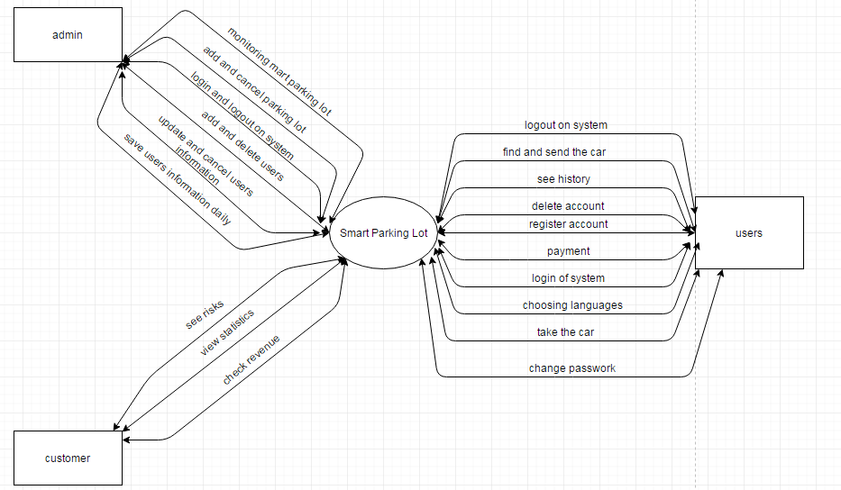

* + 1. **System Context Description**

The customer into the system: to see that equipment, to see the total revenue, to view statistics.

The users into the system: to log into the system, To choose the language, to register and delete accounts, to change passwork, to find and send the car, to take the car, to payment and logout of the system.

The admin into the system: to login and logout on system, to add and delete users, to add and cancel parking lot, to monitoring mart parking lot, to update and cancel users information, to save users information daily.

* 1. **Use CaseDiagram**

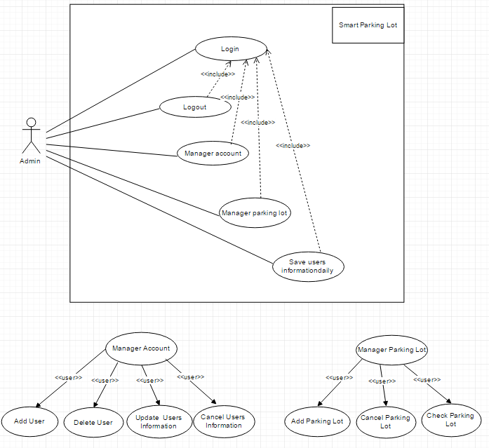

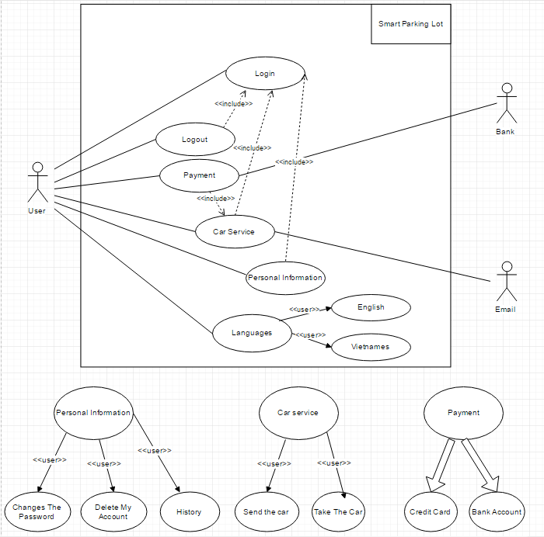

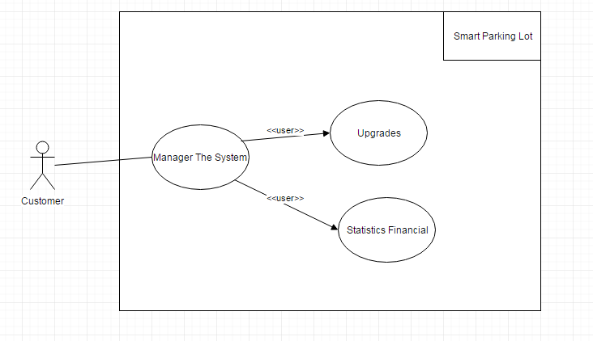

1. **NON-FUNTIONAL REQUIREMENTS (QUALITY ATTRIBUTES & THEIR PROPERTIES)**

* **Performance Requirements**

|  |  |
| --- | --- |
| PE-1: | The system sends a conformation email within 15 seconds of placing the parking |
| PE-2: | The system can handle up to 2000 users during official work hours from 1:00 am to 23:00 pm |
| PE-3: | When clicking on the icon the system responds within 1 seconds |
| PE-4: | Fingerprint verification system for 2 seconds. |

* **Safety Requirements**

|  |  |
| --- | --- |
| SE-1: | Parking place must absolutely stable and qualified |
| SE-2: | Parking location must be to check then for operational |
| SE-3: | the system no fault will be put into operation |
| SE-4: | The car checked comprehensive by lasers. Safety car will be allowed parking |
|  |  |

* **Security Requirements**

|  |  |
| --- | --- |
| SE-1: | Logging in is required for placing parking |
| SE-2: | All transactions that include personal information are encrypted |
| SE-3: | Each user is given a password |
| SE-4: | Customers is the only people authorized to change the menu |

* **Software Quality Attributes**

|  |  |
| --- | --- |
| Availability-1: | The system is available for usage 23 hours a day, 7 days a week. |
| Robustness-1: | Not only should the system work in a correct way in each situation, it should also resist against any possible user-misbehavior or error in its surroundings. |

1. **EXPECTED OUTCOME**

Our products bring many tremendous utilities. It reduces traffic congestion, save time and space. it convenient for car parking, payment easy, high security system so secure for cars.

1. **METHOD/APPROACH**

This project, we use Waterfall process to develop the application.

**5.1. Process oveIn trview**

The waterfall model is a sequential (non-iterative) design process, used in software development processes, in which progress is seen as flowing steadily downwards (like a waterfall) through the phases of conception, initiation, analysis, design, construction, testing, production/implementation and maintenance.

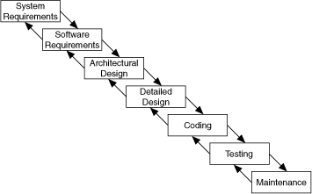

The waterfall development model originates in the manufacturing and construction industries: highly structured physical environments in which after-the-fact changes are prohibitively costly, if not impossible. Because no formal software development methodologies existed at the time, this hardware-oriented model was simply adapted for software development

The following list details the steps for using the waterfall model:

* + System requirements—Establishes the components for building the system, including the hardware requirements, software tools, and other necessary components. Examples include decisions on hardware, such as plug-in boards (number of channels, acquisition speed, and so on), and decisions on external pieces of software, such as databases or libraries.
  + Software requirements—Establishes the expectations for software functionality and identifies which system requirements the software affects. Requirements analysis includes determining interaction needed with other applications and databases, performance requirements, user interface requirements, and so on.
  + Architectural design—Determines the software framework of a system to meet the specified requirements. The design defines the major components and the interaction of those components, but the design does not define the structure of each component. You also determine the external interfaces and tools to use in the project.
  + Detailed design—Examines the software components defined in the architectural design stage and produces a specification for how each component is implemented.
  + Coding—Implements the detailed design specification.
  + Testing—Determines whether the software meets the specified requirements and finds any errors present in the code.
  + Maintenance—Addresses problems and enhancement requests

After the software release. In some organizations, a change control board maintains the quality of the product by reviewing each change made in the maintenance stage. Consider applying the full waterfall development cycle model when correcting problems or implementing these enhancement requests.

* Advantage:
  + Easy to assign work, distribution costs, monitoring of work
  + System architecture stability
* Disadvantages:
* The relationship between the stages are not shown.
* Must end at each stage so difficult to implement full requirements of customers because in this model is very difficult to change the implementation phase.
* The only contact with the customer in the required phase should take the software does not meet all the requirements of customers.
* Development costs are relatively large.
* High possibility of failure.

## 5.2. Tool and technical

* Programing: PHP, Laravel 5.xx framework.
* Web server: Linux/Debian.
* Operating system: Window 7 or higher, mobile.
* Develop tools: PHP storm, mysql workbench.
* Database: MySQL.
* Internet Connection.

1. **WORK BREAKDOWN STRUCTURE**

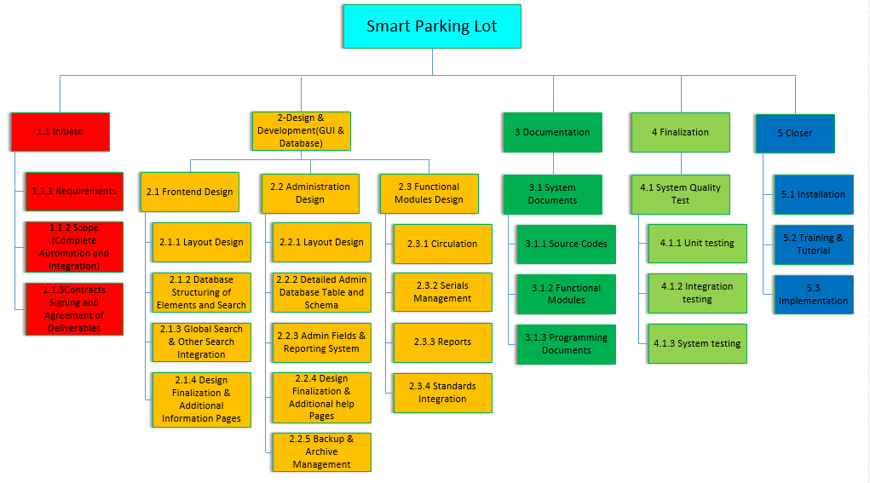

1. **PLAN**

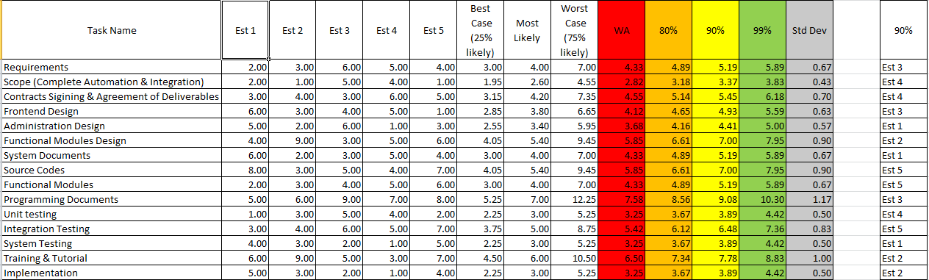

1. **REQUIREMENT PHASE**

